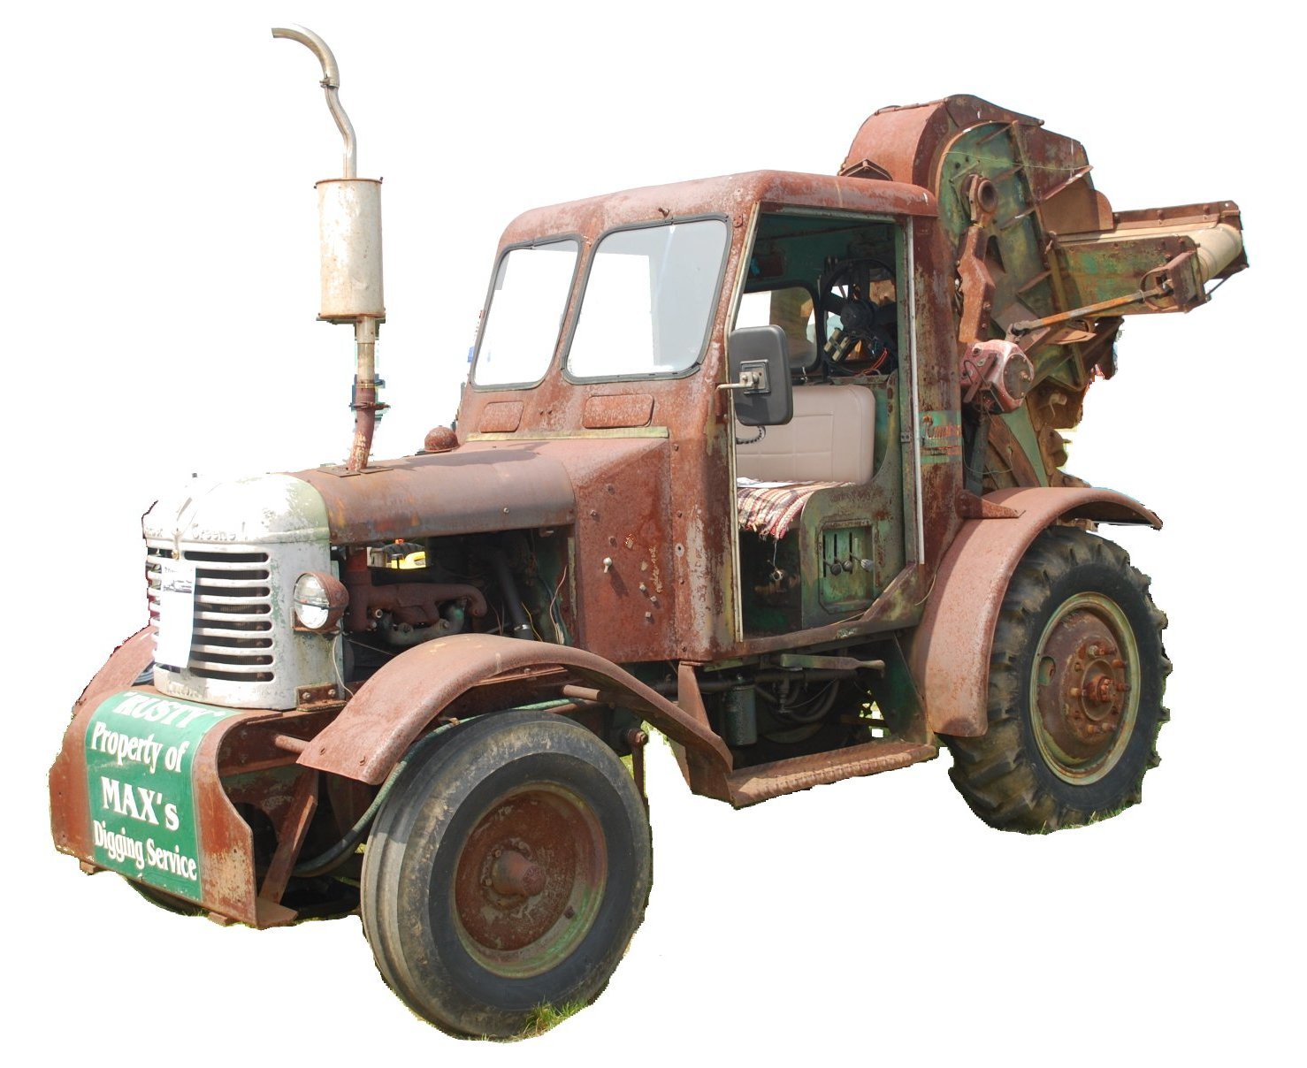
F O O T H I L L S

ANTIQUE POWER ASSOCIATION
ESTABLISHED 2003

March 2017
Dear Members,
It is March already – only two months away from show time. That means we really need to get busy getting everything prepared and in place. As such, we must rely on as many members as possible doing what they are able and willing to do to ensure all that is necessary so we will be ready.
It may surprise you, but only about 30 members accomplished nearly all the preparation and work necessary for the last show. That is a good average for all our previous shows, but with over 370 members, you’d think a few more would be willing to step up and help.
--- --- --- from the March meeting --- --- ---

- Struggles and challenges are nothing new to any of us. These bodes of ours age, grow weak, and seem to be susceptible to all kinds of troubles. None of us are immune, but it seems from time to time that some have more than their fair share. We pray for them and we pray for each other, for comfort in afflictions, for peace in tribulations, for strength in weakness, and for wisdom when troubled.

  - Max Lee
  - Reba Reinhardt
  - Horace Isenhour
  - Doug Huffman
  - Jacqueline Hilliard
  - Cole Abernathy
  - Ann Little
  - Kenneth Beach
  - Vee Williams
  - Claude & Sylvia Wilson
  - Larry Sigmon
  - Donnie Elmore
  - Vicki Hastings
  - Lorna Sheets
  - Billie Sue Goforth
  - Steve Hefner
  - Wade Hefner
  - Norris Turner
  - Terry Martin
  - Eugene Hartley

  - Ira & Ann Cline
  - Howard Cooper
  - Kelly Blanton
  - Rev. Bobby Langston
  - Don Johnson
  - Carl Porter
  - Jane Abernathy
  - Kay Nash
  - Lilian Setzer
  - Daniel Schronce

--- --- --- 2017 Show preparations --- --- ---
- Ads, ads, ads.
  - Tee-shirt sponsors need to be verified and their information and monies submitted AS SOON AS POSSIBLE. We really need this within the next couple weeks in order to get the layout completed so printing can begin.
  - Program ads and articles also should be in soon. April 15 is a definite final date for everything.
- Signs, signs, signs!
  - Please check your garages, porches, vehicles, and any other place for signs not returned after last (or any previous) year’s show. We need them returned AS SOON AS POSSIBLE so they can be updated with 2017 dates.
  - Handouts for the 2017 show are READY. You can get them at the monthly & show committee meetings, or at Sig’s Tire.
- The Show Committee is working hard on preparing for the 2017 show, but there is still much to be done before show time. With the help of as many members as possible, we can avoid the usual last minute rush to get it all done.
  - The Show Committee has acquired 3 more sets of bleachers for the Pulling Track area. This will enable us to seat more people for the upcoming events. A larger than normal crowd is expected since we are adding the Modified Road Tractors Pulling to our Exhibition Pull.
  - The Show Committee meets regularly on the 3rd Thursday of every month. Everyone’s help is welcomed and encouraged.
- The work has begun on the sawmill shed and, weather permitting, should be completed by the end of the month. The new look should make a big difference in the appearance of the fairgrounds. We appreciate the American Legion Fair providing a significant part of the total cost.
- The American Legion Fair was recently awarded the Innovation Award from the NC Association of Agricultural Fairs. This award was presented in large part on account of the efforts of the FAPA during the fair and but our building efforts. Particularly cited were the General Store, the sawmill, and the steam engine.
- If you have not renewed you membership for 2017, remember, dues are to be paid as of January 1.
  - Tim Hollar and Butch McIntyre are still overseeing the collection of dues. You can pay them at the monthly meetings, at Hollar Tractor, or Sig’s Tire, or you can send your $20 check to the club’s mailing address (below).

--- --- --- UP-COMING EVENTS --- --- ---

Mar 16 Sig’s Show Committee meeting
Mar 25 Dallas Cotton Ginning Days Swapmeet
Apr 6 Sig’s April Monthly Meeting
Apr 7 Catawba Bandys HS FFA Ag Day
Apr 14-15 Turnersburg Spokes & Cleats Swapmeet
Apr 20 Sig’s Show Committee meeting
Apr 27-30 Gray TN Tri-State Antique Power Show
May 4 Sig’s May Monthly meeting
May 19-20 Newton FAPA show

☺ ☺ !!!!! HAPPY BIRTHDAY !!!!! ☺ ☺


March birthdays

3 – Kenneth Cannon
8 – Keith Little
11 – Gary Detter
12 – Rahn Painter
19 – Jason Icard

20 – James Couch
23 – Buddy Huffman

April birthdays


1 – Richard Blume
1 – Duane Webb
2 – James Reinhardt
3 – Bobby Franklin
3 – Dexter Sprouse
4 – Brent Henley
6 – Dennis Back
6 – Bryan Warner
12 – Charles Lynch
16 – Johnny Hollar
16 – Linda Sigmon
17 – Blake Herman
19 – Michael Dagenhardt
19 – Debbie Yelton
21 – Fred Little
26 – Kermit Nash
27 – Kelly Pope
28 – Angela Schronce
30 – Butch Fox
30 – Kyle Sigmon

-- --- --- THE CLASSIFIEDS --- --- ---

Is there anything you would like to sell or are you looking for something special? List it here.
(Item listings will run for 3 months before expiring. Let us know when an item is sold or bought.)

WANTED Allis-Chalmers B engine, Troy Elmore (16-10)

FOR SALE

Allis-Chalmers G taillight, NOS,
Butch Fox (828) 4566-3940 (17-01)

A Farmall l948?, $800.00, Hal Lail, 465-1147 (17-03)

Bolens Ride Master, all original, $700;
Butch Fox (828) 4566-3940 (17-01)

Wards walk-behind tractor 3-spd, all original,
Butch Fox (828) 4566-3940 (17-01)

-- --- --- something to think about --- --- ---

Some of us, at this time of year, celebrate the season of Lent – a time of reflection. With that in mind, here are a few thoughts upon which to reflect.
What do we have that has not been given to us by our Lord and our God?
What are we but that which we have been made to be by our Lord and our God?
What have we to give but that which has been given to us by our Lord and our God?
What is worth keeping but that which has been entrusted to us by our Lord and our
God?
What more can we give than that which has been given for us by our Lord and our
God?
What more do we need than our Lord and our God?
For those who know Christ – I mean those who really know Christ Jesus our Lord, not just who he is, but all that God has done for us and in us through him, and those who seek to learn more of him every day, we must answer all of these questions without hesitating with an unequivocal “nothing!” If our answer is anything but this, we do not know Christ Jesus, the Lord of Glory.
Consider this, not just during Lent, not just on Sunday morning, but each and every day. The world around us (and in us) will constantly endeavor to convince us that we need to do more, that we need to give more, that we need more.
But, the simple truth is this: my Lord and my God are more than enough.
God bless you all.
See you in April
Your Secretary, David Setzer

President: Kevin Black 828-464-1950 Vice Pres: Wilson Sigmon 828-256-2176
Treasurer: Kermit Nash 828-459-9616 Secretary: David Setzer 828-850-4943
Show Chair: Teddy Hefner 828-310-5525 Asst. Show Chair: Anthony Austin
Asst. Secretary: Kevin Sigmon 828-256-21

Board of Directors: Phillip Spencer, Howard Reinhardt, Ned Story, Teddy Hefner, Tim Hollar, Butch McIntyre

Foothills Antique Power Association
5851 St. Peter’s Church Road, Conover, NC 28613 Foothillsantique.com
It is time to begin pre-registration for the 2017 show. Using this for ahead of time will greatly simply the process of registration during the show.

Foothills Antique Power Association
^{14th} annual Antique Power Show May 19-20, 2017
Exhibitor pre-registration form

Name: _________________________________________
Address: _______________________________________
City, State, Zip: __________________________________
Phone: _________________________________________
Email: _________________________________________

Year Description Placard? (circle)

______ ________________________________________________ Color B&W

______ ________________________________________________ Color B&W

______ ________________________________________________ Color B&W

______ ________________________________________________ Color B&W

______ ________________________________________________ Color B&W

______ ________________________________________________ Color B&W

______ ________________________________________________ Color B&W

______ ________________________________________________ Color B&W

______ ________________________________________________ Color B&W

Total number of color placards desired ______ @ $2.00 ea = _________

Use back if more room is needed.
Pre-printed color placards are laminated and @2.00 each. B&W placards are no charge. If placards are desired, please indicate your preference.

Please complete and return by May 1.
Forms and color placard payment can be mailed to Foothills Antique Power Assoc. at the address below, or they may be delivered to David Setzer or Kevin Sigmon at the regular meetings, show committee meetings, or via Sig’s Tire.
5851 St. Peter’s Ch. Rd. Conover, NC 28613 - www.foothillsantique.com

